1. Backup up your database once.

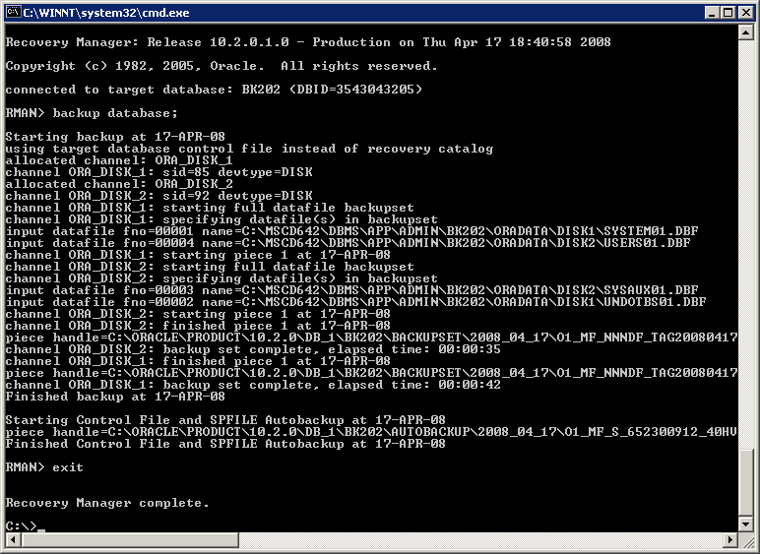

2. Run this query to gather performance statistics:

SET LINESIZE 1000
COLUMN session_recid FORMAT 999
COLUMN input_bytes_per_sec_display FORMAT a20
COLUMN output_bytes_per_sec_display FORMAT a20
COLUMN time_taken_display FORMAT a20
COLUMN end_time FORMAT a20
SELECT session_recid, input_bytes_per_sec_display,
output_bytes_per_sec_display,
time_taken_display, end_time
FROM v$rman_backup_job_details
WHERE session_recid > 296
ORDER BY end_time;

(note: I used the session_recid > 296 in order to clean up my results and only show backups from the course of this project’s purposes)

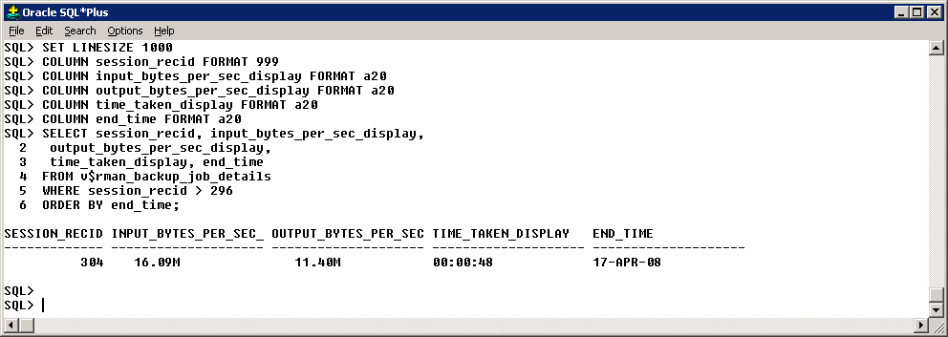

3. Use the RMAN to configure incrementally updated image copies.

This should set up the initial image copy. RMAN will not find an initial image copy to update in the RECOVER command, so the BACKUP command will create one for each datafile.

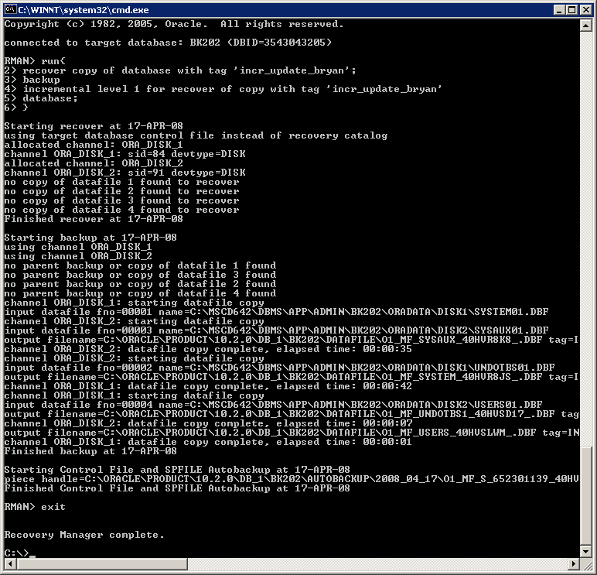

This will have to be run once more before it detects anything as it is looking for a level 1 backup, and we only have a level 0 backup.

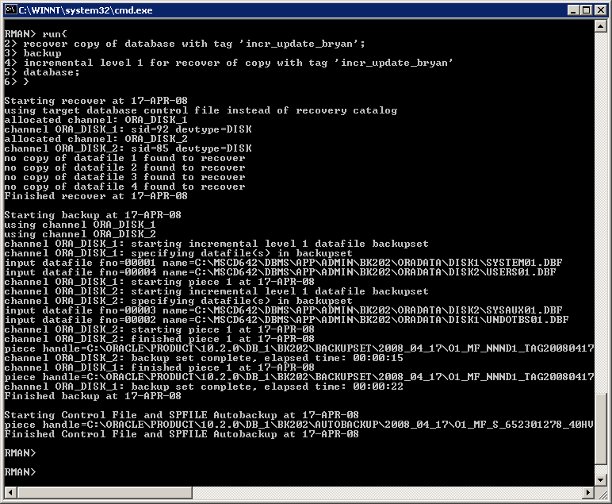

Now everything should be ready for incremental level 1 image copy backups.
4. Run five backups of your database.
I will use the same script as the initial one to run the backups.

#1
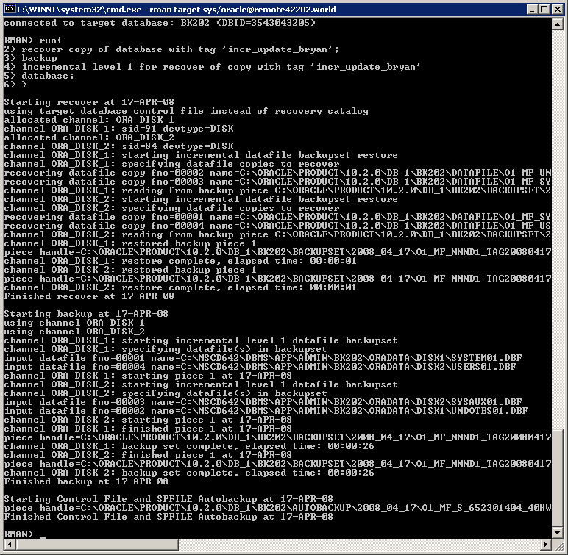

#2 This, and all the backups following, should detect a level 1 backup and incrementally update the image copy.

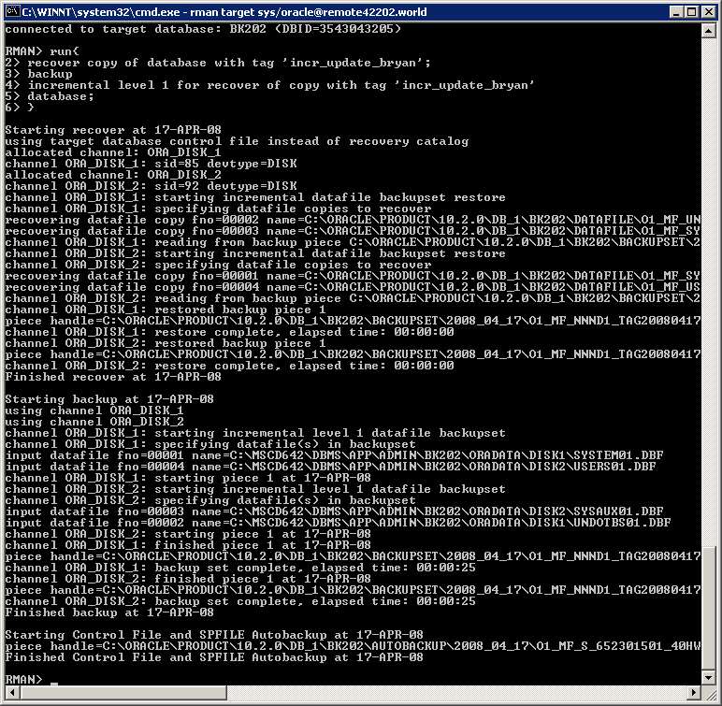
#3

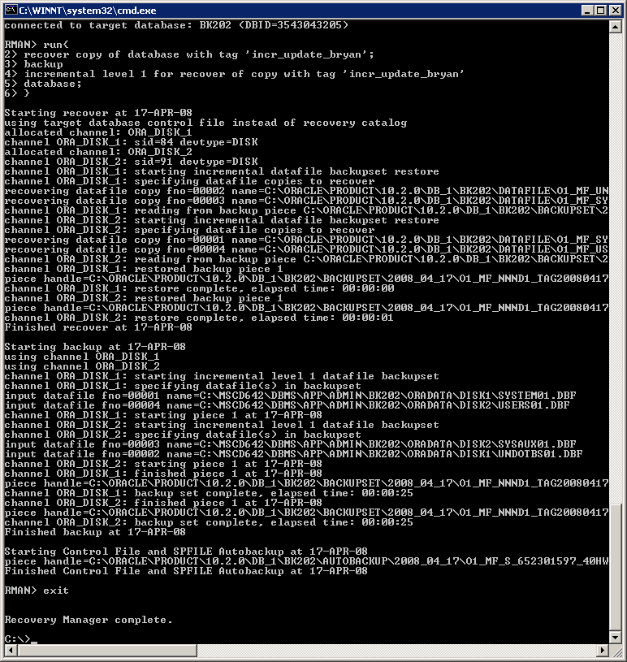
#4

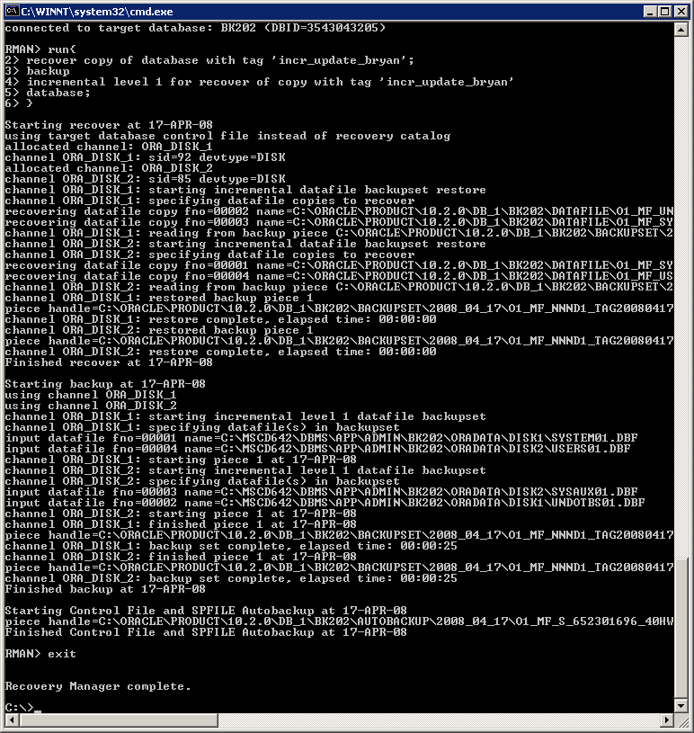
#5
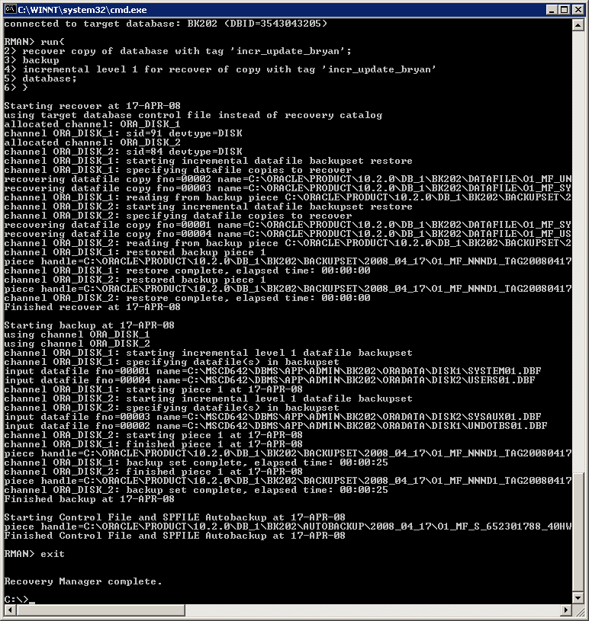
5. Gather performance statistics again. Did performance increase or decrease?

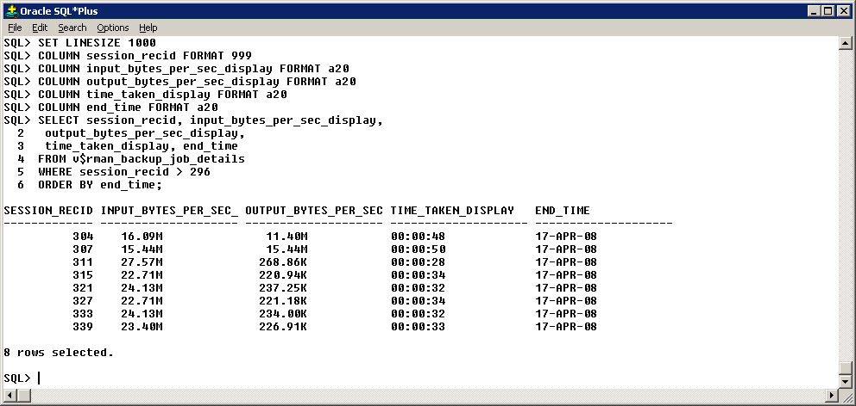

(304 is my full backup, 307 & 311 are the backups for my first level 0 backup, and the first incremental backup in which the level 1 was created. The remaining backups are my 5 backups from step 4).

I would say the performance increased from the full backup (taken in step 1). The incremental backup was able to read in more data faster, which is important as an incremental backup is reading for the changes, so will read more often than a full backup. The output speed (of 307) was also faster than the full backup (304) when performing a level 0 backup. The output speed of the subsequent are slower, but I can only assume that is because there were no changes made to the database and there was no significant changes to the datafiles. With the exception of the initial level 0 image copy (307), the time taken for the incremental backups was all faster than the initial backup performed in step 1.

6. What recommendations would you make for improving performance?

Block change tracking can be used to improve the performance of an incremental backup. This feature records, in a specified file (the file contained in the db_create_file_dest parameter), the changed blocks within datafiles since the previous incremental update. Instead of searching through the entire datafile for changes, RMAN can simply read these values from the db_create_file_dest file and apply those changes through the incremental update. This feature is disabled within Oracle by default, but is enabled by setting the db_create_file_dest parameter and issuing the command:
Alter database enable block change tracking;

